FSSS U# 1 & 2

**INTRODUCTION:-**

FSSS is designed to ensure a safe orderly start-up and shut down sequence of the fuel firing equipment to prevent errors of omission during execution of these operating sequences.

This system provides safely interlocks to protect against potential emergency situations in the event of malfunctioning of fuel firing equipment and associated air systems. The safely features of this system are designed for protection in most common emergency situations. This system cannot replace the judgment of the operators in all situations.

The various functions of the system are:-

1. Ensure that a satisfactory furnace purge cycle has been completed prior to firing any fuel.
2. Prevent start-up of individual fuel firing equipment unless certain permissive interlocks have first been satisfied.
3. Monitor and control the proper component sequence during start-up and shutdown of fuel firing equipment.
4. Ensure that certain safely interlocks remain satisfied during operation of fuel firing equipment.
5. Provide component status feedback to the operator the unit control system and data logger.
6. Provide flame monitoring when fuel firing equipment is in service.
7. Initiate a fuel trip when certain abnormal operating conditions exist.

It is essential that all parts of the furnace safeguard supervisory system are in operable condition and in service at all times if the system is to provide the function for which it was designed. Provide inspection and proper maintenance of the system and associated hardware is essential for its continued reliable operation.

FSSS is designed based on use with boiler of single furnace, natural circulation, tangentially fired type with pressurized pulverizes system.

This system provides for the remote manual operation of three elevations of High Energy Arc (HEA) Igniters, three elevations of oil guns with provision for firing light oil in Ek. AB only, heavy oil on Ele. AB, CD and EF, and six elevations (A,B,C,D,E,F) of coal nozzles (4 at Each ele- Total 24 Nos) along with their associated P.A. Fan, system and Feeders. Indicating lamps on the console incepts show the operating status of the various field equipments.

The following operational functions are included in FSSS.

1. Furnace purges supervision.
2. Secondary air damper modulation ON/OFF control and supervision.
3. Light oil ON-OFF control and supervision.
4. Seal air fans ON-OFF control.
5. PA Fan ON-OFF control.
6. Pulverizer and feeder ON-OFF control & supervision.
7. Flame scanner intelligence and checking.
8. Overall boiler flame failure protection.
9. Boiler trip protection.

**COAL ELEVATION:- A & B C & D AND E & F**

To operate furnace of 210 MW with rated pr. There are six elevations of coal i.e. A, B, C, D, E, F nozzles. Each one nozzle is provided at per corner per elevation. Boiler is fired tangentially from four corners. So total no. of 24 coal nozzles are provided to a furnace. One mill provides pressurized pulverized coal power at one elevation thro’ four nozzles at one elevation i.e. coal mill A at coal ele A. Each individual pulverize has its own P.A. Fan system and coal feeder circuit.

In P.C.R. three coal elevations panel are provided, first for coal elevation A & B, 2nd for C&D and third for E&F. Each panel supervises and control two pulverizes with its associated P.A. Fan system and feeder.

One panel of coal elevation A&B consists door panel racks and inside Relays in distributed in rows (+24V) and T.B. wiring.

To have feeder control on auto and manual separate three panels are provided. Each consisting of control ckt for two feeders. First F.C. panel for A & B feeder, 2nd for C & D feeder, 3rd for E & F feeder, situated in P.C.R.

At local near pulverize Lub oil pump control panel is provided for each mill which consists of control ckt with relays to control two lub oil pumps with auto pick up facility.

**COAL ELEVATION A & B DOOR PANEL**

|  |  |  |  |  |  |  |  |  |  |  |  |  |  |  |
| --- | --- | --- | --- | --- | --- | --- | --- | --- | --- | --- | --- | --- | --- | --- |
| RACK A | +-24V D.C. Power Supply Distribution and Supervision Cards (Module) +24V  - 24V  AVS+24  GND | | | | | | | | | | | | | |
| RACK B | Feeder and Hot air Gate Logic Cards Ele. A | | | | | | | | | | | | | |
| RACK C | Pulverizer logic Auto seq. start/stop Ele. A | | | | | | | | | | | | | |
| RACK D | Buffer Drives ele. A. | | | | | | | | | | | | | |
| RACK E | P.A. Fan logic ‘A’ Input Module For Ele. A | | | | | | | | | | | | | |
| RACK F | Feeder and Hot air gate logic Cards Ele. B | | | | | | | | | | | | | |
| RACK G | Pulverizer logic Auto seq. start stops Ele. A | | | | | | | | | | | | | |
| RACK H | Buffer Drives Ele. B | | | | | | | | | | | | | |
| RACK I | P.A. Fan logic ‘B’ Input Module for Ek. B | | | | | | | | | | | | | |
| RACK J  Matrix, Drive Cards, Amplifier | Matrix  ‘A’ | Amplifier  ‘A’ | P.A. Fan  A | Pulverizer  A | Mill Discharge Valve A | Feeder  A | Hot Air Gate  A | Matrix  B | Amplifier B | P.A. Fan B | Pulverizer B | M.D.V. B | Feeder B | Hot Air Gate B |

Each Rack contains Electronic Cards consisting of AND Gate, OR Gate, Timer of pulse of various time setting, Flip-Flop (R-S). Logic for pulverize P.A. Fan & Feeder, Auto start/stop are formed thro’ these Cards. These cards are also serve the purpose of input modules & buffer Drives with LED ON/OFF, OPEN/CLOSE & other status with description of which replica is available on P.C.R. control Desk.

**SUPPLY DISTRIBUTION To Coal Ele. A & B Panel**

1. 110V A.C. Supply Distribution to Coal ele. A & B Panel.

TB TBP

STN. EME 110VAC ACDB 1 5 PHASE 110V A.C. TO COAL

RGENCY BOARD IN PCR N 6 Neutral ELE. A &B

415/110V DISTRIBUTION &

SCANNER PANEL

TBP 110V A.C 50 HZ

TO COAL for Pulverizer

Neutral ELE. A Discharge Valve

HOT Air Gate

TO COAL Seal Air Valve

ELE B K37A a

F1B b Ele. A.C. 110V

Available

110V A.C. from Panel is used to operate pulverize discharge valve, Hot air gate & Seal air valve of coal etc.

+24 v Feeder 1

AVS Supply

+24v Feeder2

M (GND)

-24v Feeder 1

-24v Feeder 2

For +-24V D.C. supply for positive logic of cards and negative supervision and also for   
+24V D.C. relay operation, a separate D.C. distribution unit with its supervision circuit is provided in Each panel of coal elevation A & B at PACK A. +- 24V DC Two incoming feeders, Feeder 1 & Feeder 2 are taken from +-24 Battery charge 1 & 2 respectively.

If any one of two feeder trip still +-24vDC supply is available from other feeder. Input to +-24VDC distribution and supervision module in RACK A is thro’ MCB Q1 & Q2 for +24VDC and Q3 & Q4 for -24V. The output supervision supply is available at MCB Q11, Q12, and Q13 for positive 24V and Q14 & Q15 for -24V and GND (M).

Four Bus-Bars are formed for each RACK in Ele. A. as +24V, GND or M, -24V & +24V from Top to Bottom Bus1 (B) Bus 2 (D) Bus 3 (F) Bus4 (H).

There are four rows of relay (+24VDC) having total no. of 78 relays. Upper two rows i.e. K14 to K39A for coal ele. A and lower two row i.e. K1B to K39B for coal ele. B. M-1, M-2, M-3 & M-4 (GND BUS) are formed for the operation of relays for (4) GND and +24V D.C. is made available at terminal 2(a) of relays.

**COAL ELE. A: P.A. Fan A & Pulverizer A Permissive**

Pulverizer O/L Temp. <94°C

(U) PULV/Feeder start Permit

Pulv. Discharge Valve open (P.B)

Feeder I/L Gate open F.B.

No Pulverizer Trip

No Auto Pulv. Unsuccessful start

Cold Air Gate opens F.B.

Tramp Iron hopper Valve open F.B.

(U) Pulverizer Ignition Permit

(Primary Air permits Pulverizer OFF (F.B.))

All Burner I/L Shut Off Gates open

Lub oil permissive available

P.A. Fan start command

(U) No MFR Trip

Seal air HDR/Pulv. Bowl D.P. O.K

Hot Air Gate closed F.B.

P.A. Fan I/Damper in Min position

|  |
| --- |
|  |

Cold Air Damper <5° open

* P.A. Fan ready signal for Desk Indication & P.A. Fan Interlock ‘ON’ to Drive Card (JC27) to get P.A. Fan ‘ON’
* Pulverizer Ready (1b20) to Drive Card (JC39) to get Pulv. Read ‘ON’ after pressing Desk P.B. ‘ON’
* P.A. Fan start Command goes to close P.A. Fan Inlet damper
* All above signal goes via. Amplifier Card (AND) JC 15.

DRIVE CARD (P.A. Fan, Pulv, Hot air, Feeder and Pulv. Discharge Valve)

There are six Drive cards whose output drives relay (+24V) for starting and stopping the auxiliaries & to extent 110V supply to close or open hot air gate. Interlock ON

**Ele. A DRIVE CARD JC**

Desk Start P.B. 1b20 Relay TBA

ON Auto K1 5

Order O 6 Relay

+24V Desk Stop P.B. K2 7

Auto Order OFF OFF

Protection OFF

The ‘Output Contacts’ of Relay (+24V) is used in the closing and tripping circuits of 6.6KV BKr. When control from Remote for P.A. Fan & Pulverizer.

For Hot air gate, 110V supply is extended to solenoid to open or close the gate thro’ relay contacts form F.S.S.S. T.B.

For Feeder control, drive card output picks up relay (K-5), whose ‘Make’ contact is used in the start circuit of Feeder MCC when control form remote. When OFF command is given, relay drops, Break contact stops feeder thro’ 110V control ckt. Of 415V MCC.

For pulverize Discharge Valve control, 110V A.C. is extended to solenoid for open & close operation of discharge valve.

ON/OFF of OPEN/CLOSE F.B. is coming to Drive Card with or from 6.6KV BKr or local limit switches.

**P.A FAN CONTROL**

**STARTING:-**

P.A. Fan ready condition has to be established before starting the P.A. Fan. The P.A. ready amber lamp glows when all conditions are present such as

1. NO MFR TRIP.
2. Pulveizer Ignition permits available.
3. Hot air gate closed.

Before starting P.A. Fan, ensure that 6.6KV BKr. Circuit is OK i.e. Local P.B. in released condition, 220VDC ON, Selector switch is on ‘Remote’, all motor protection trip ckt supervision, Master Trip relays are resetted. Also process closing interlock is available (P.A. Fan BRG. TEMP NOT HIGH)

When P.A. Fan ‘ON’ push button is pressed or auto start command comes, the respective cold air damper will go to less than 5° open position and seal air valve will get open command. Both conditions –

1. Seal air to Bowl D.P. O.K.
2. P.A. Fan Inlet damper is closed.

Will give P.A. Fan Interlock ON and then P.A. will get start command. P.A. Fan ‘ON’

Is indicated by ‘Red’ lamp on the console the P.A. Fan inlet damper control is released to automatic operation

.. Relay ON T.B.A. B.B-1 BKr ‘ON’

DESK P.A.Fan Drive card K8 9 28 Closing ckt

P.B.ON P.A.Fan P.A. Fan OFF BKr ‘OFF’ Tripping ckt.

Desk P.B OFF J C 27 K9

Coal Ele. A. FSSS 6.6 KV BKr T.B 1

P.A. Fan can be started from local P.B. by putting Bkr. Selector switch on ‘MOTOR’, provided process closing Interlock is available & BKr relays are resetted. This ‘Local start’ Facility is removed. P.A. Fan can

Relay T.B.’A’ FSSS LOCAL

SEAL AIR VALVE OPEN 11

COMMAND FROM 43/3 DRIVE 12 OPEN SOLEN 01 D

SEAL AIR VAWE CLOSE CARD 13 CLOSE

COMMAND FROM 43/3 EC 75 (Pneumatic valve)

Coal Ele. A PH 110V A.C Seal air

SEAL AIR VALVE CONTROL

Seal air valve opens only when P.A. Fan start command is given or P.A. Fan auto ‘ON’.

Seal air valve gets close command if P.A. stopped manually or auto. It closes when the following conditions are preset.

1. Hot air gate closed.
2. P.A. Fan Inlet damper in minimum position.
3. C.A.D. less than 5° open
4. Pulverizer off.
5. Hot air Gate closed.
6. P.A. Fan is off.

**P.A. FAN TRIPPING:-**

The running P.A. Fan will trip if anyone of the following conditions exists:-

1. MFR TRIP
2. Pulverizer Trip
3. P.A. Fan Auto stops command.
4. “Process Trip”- P.A. Fan Brg. Temp. V High
5. P.A. Fan Motor Protection Trip

In emergency, P.A. Fan can be stopped by persists Emergency Trip P.B. from local or by pulling manual lever for ‘Manual opening Bkr’ at switchgear panel.

Seal air valve gets close command as such as P.A. is stopped.

**HOT AIR GATE CONTROL:-**

Hot air gate is solenoid operated at 110VDC. It is closed or opened manually form Desk. It also closes when following conditions exists on auto.

1. Pulverizer off.
2. Feeder off pulse.
3. Pulverizer outlet temp > 94°C
4. Auto close command.
5. Manual P.B. closed.

Relay

ON FSSS TBA Local

HAG OPEN Desk P.B DRIVE K6 N 23 open

HAG CLOSE CARD HAG K7 24 solenoid

COMMAND DESK P.B ‘A’ JC75 OFF 25 close

110V

HAG CONTROL

Hot air gate opens only when ‘ON’ Feedback from pulverize ‘ON’ is available with HAG ‘OPEN’ command manual or on auto. Air and Temp. Control is released on auto when HAG opened with pulverizes ON.

Hot air damper gets close command when hot air gate is closed with Pulverizer OFF.

Feedback AT FSSS T.B.A.

ON

45 TO 41 TO

46 ON DRIVE 42 DRIVE

47 OFF CARD 43 CARD

OFF

**PULVERIZER CONTROL**

**PULVERIZER IGNITION PERMIT**

Prior to starting any pulverize the pulverize ignition energy must ve adequate to support coal firing. This is accomplished as follows:

**PULVERIZER ‘A’**

1. A minimum of 3 of the 4 elevation AV Heavy oil nozzle valves proven open.

OR

1. Boiler loading greater than 30% and pulverize B is in service at greater than 50% loading.

**PULVERIZER ‘B’**

1. A minimum of 3 of the 4 elevation ‘AB’ Heavy oil nozzle valves proven open.

OR

1. Boiler loading is greater than 30% and pulverize ‘A’ or ‘C’ is in service at greater than 50% loading.

**PULVERIZER ‘C’**

1. A minimum 3 of the 4 elevation CD heavy oil nozzle valves proven open.

OR

1. Boiler loading is greater than 30% and pulverize ‘B’ or ‘D’ is in service at greater than 50% loading.

**PULVERIZER ‘D’**

1. A minimum of 3 of the 4 elevation ‘CD’ heavy oil nozzle valves proven open.

OR

1. Boiler loading is greater than 30% and pulverize ‘C’ or ‘E’ in service at greater than 50% loading.

**PULVERIZER ‘E’**

1. A minimum of 3 of the 4 elevation ‘EF’ heavy oil nozzle valves proven open.

OR

1. Boiler loading is greater than 30% and pulverize ‘D’ or ‘F’ in service at greater than 50% loading.

OR

1. A minimum of 3 of the 4 elevation CD heavy oil nozzle valves proven open and pulverize ‘D’ is in service at greater than 50% loading.

**PULVERIZER ‘F’**

1. A minimum of 3 of the 4 elevation ‘EF’ heavy oil nozzle valves proven open.

OR

1. Boiler loading is greater than 30% and pulverize ‘E’ in service at greater than 50% loading.

**PULVERIZER READY**

Prior to starting a pulverize a pulverize start permit condition for the respective pulverize must be established by confirming following condition.

1. D.C. Power available (+24V)
2. Nozzle title placed n horizontal position.
3. Air flow adjusted between 30% and 40% MCR.

**NOTE:** Conditions ii) &iii) are bit required to be satisfied for a pulverize ready condition when any feeder is already proven on. However, the operator is still restricted ot a minimum air flow above 30%.

1. At the respective pulverize following conditions are to be satisfied. Each condition is shown by white light.
2. Pulverize discharge valve open.
3. Pulverize outlet temperature < 94°c.
4. Cold air gate open.
5. No pulverize trip.
6. Tramp iron hopper valve open.
7. Feeder inlet gate open.
8. P.A. Fan ON.
9. Pulverize/Feeder start permit.
10. Seal air to Bowl P > 8” WC i.e. D.P.O.K.
11. All burner gates open.
12. No auto pulverizes on successful start.
13. Lubrication oil permissive O.K.
14. Pulverize off.

When all the above conditions are satisfied for the respective pulverize its associated pulverize ready light (white) comes ON.

**PULVERIZER START (MANUAL MODE)**

Pulverize can be started pressing pulverize ON push button pulverize will start provided pulverize ready condition is preset.

When the pulverize is proven on as indicated by the ‘Red Pulverize ON’ light coming on, open the hot air gate by pressing its OPEN push button & allow the pulverizes to come up to the temperature.

When the pulverize comes up to temp. 47° C start the feeder by pressing its associated ‘ON’ push button (The associated elevation of fuel air damper proven closed).

Coal flow must be proven either by the coal on belt signal or by satisfactory pulverize current within 5 sec after the feeder is started. Fifteen seconds after the feeder is started the feeder output is released to the fuel totalizing ckt.

When a minimum of two feeders are established at greater than 50% loading the associated elevation of oil elevation may be shutdown provided the feeder has been on for a minimum of 3 minutes.

**OPERATOR MODE:** - A single feeder in service for fifty seconds at its minimum speed setting will establish a fireball in the furnace.

(a single fireball is established when a coal elevation is placed in service. when additional coal elevation are placed in service, this single fireball is merely enlarged. If the support ignition energy is removed, the fireball will be monitored by associated elevation flame scanners. However, operator procedure dictates that adjacent feeder be placed in service and both feeder speeds be increased to 50% before removing the support ignitions energy (i.e. oil guns in rle) to ensure the intensity and self support of the fireball. Good operator procedure dictates that the second feeder in service be no more than once removed from the one already in service. When removing feeders from service the inverse procedure should be followed and support ignition energy should be in service when only two feeders remain in service at 50% feeder speeds.

# PULVERIZER TRIP SIGNALS

Pulverize Trips on following conditions:-

1. Loss of unit critical power +24V.
2. Pulverizer Ignition permits not available.
3. Master Fuel Trip Command i.e. Boiler Trip.
4. P.A. Fan Trip.
5. Loss of devotion D.C. (+24 V).
6. Loss of primary air.
7. Lob oil permissive not O.K.
8. Process Tripping i.e. Brg Temp. V. High.
9. Emergency stop signal from Local.
10. Motor Protection Tripping (B-99 Relay).
11. If only on of two F.D. fan trips & more than 4 coal mills are I/S, then trip command will be given starting from the pulverize serving top most coal elevation till 3 c/mills are in service.

C/mill can be started or stopped from local by pressing emergency stop P.B.

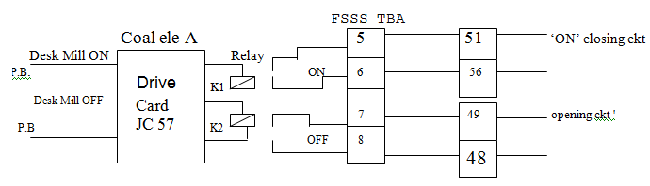

* If pulv. Motor Current is high, feeder speed comes to minimum. If Pulverizer O/L temp > 94°c, hot air damper closes & hot air gate closes on auto.
* As pulverize discharge valve is out of service. “pulv. Trip to M.D.V. Falls to open” is not I/S. Its permanent open F.B. is available for permissive on Desk.

PULVERIZER STARTING (AUTO MODE)

Pulverizer and its associated equipments (support ignition, seal air fans, P.A. Fan toured hydraulic system, not air gate and Feeder) can be started automatically in a sequential manner as described below.

First open the pulverize discharge valve manually. For starting any pulverize on auto mode the respective pulverize should be selected for auto mode of operation upon depressing the pulverize ‘ON’ push button the auto start sequence will start provided there is no “boiler trip” condition is existing in following manner.

1. A 350 sec. timer start counting the time and start command is given to the adjust oil elevation (if already it is not n service) to start on elevation mode.
2. When support elevation start time expires the seal air valve gets the start command.
3. When seal air to pulverize bowl dp> 8” wc and PA fan Ready condition is existing then P.A. Fan state.
4. The pulverize will get start command if pulverize ignition permit is available. No pulverize trip condition is existing and start sequence time (350 sec) is not expired.

Pulverizer will start if pulverize ready condition is present.

1. When the pulverize is on, hot air gate will open.
2. Feeder will start 60 sec, after the pulverize is switched ‘ON’.

If the coal flow is proven within 5 sec of starting the feeder either by satisfactory pulverizer current or coal on belt condition, the feeder will continue to be in service. Then the auto program is said to be completed then oil is support may be removed manually as explained earlier.

An unsuccessful auto pulverize start alarm is annunciated if the feeder is not on after 350 sec. Then hot air damper is closed and cold air damper is opened 30 sec. later hot air gate closed.

PULVERIZER SHUT DOWN (AUTO MODE)

Pulverizer and its associated equipment can be shut down automatically in a sequenced manner by selecting the pulverize mode to ‘Auto’ and depressing the pulverize off switch is depressed.

1. A 10 min. auto stop timer will start counting and the support ignition elevation gets start command if it is not already in service.
2. When the support ignition start time is expired, the feeder gets signal to go to minimum speed. Hot air damper gets dose command 30 sec. later hot air gets close command.
3. When the hot air gate is closed and pulverize outlet temperature fall below 120°F (47°c) the feeder will get trip command.

If any one or more of the follw9ing equipments is still on after the auto stop time (10 minutes) is expired an alarm will be annunciated.

1. Pulverizer
2. P.A. Fan
3. Hot air gate
4. Feeder.

Once on the above equipments are stopped, the oil support can be manually withdrawn.

PULVERIZER SHUT DOWN (MANUAL) Desk P.B.

The pulverizer and its associated equipments can be shut down manually by selecting “Manual” mode.

1. Start the associated oil Elevation if it is not I/S.
2. Reduce the feeder speed to minimum.
3. Close the hot air gate by depressing its “Close” push button.
4. Allow the pulverize to run for about 3 minutes to ensure that it is completely empty of coal then stop it by depressing its ‘off’ push button.
5. Stop the P.A. Fan by depressing its off push button.

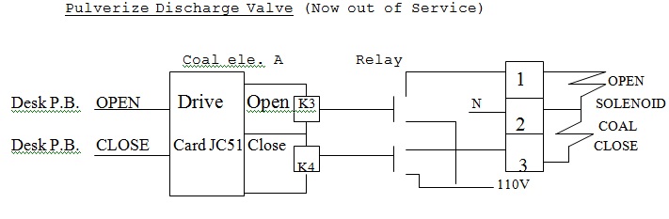

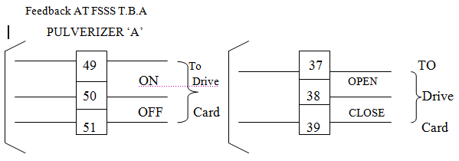

COAL MILL A LUB OIL PUMP CONTROL (MODIFIED)

Each coal mill is provided with two lub oil pumps i.e. Lip 1 and Lop 2 which can be made ‘ON’ and ‘OFF’ from P.C.R. Desk as well as from local.

One LOP is always in running condition to maintain Lob oil required pressure. Stand by pump will pick up on auto if Lub oil Pressure goes Low. Both the pumps have auto pick up facility coal mill will trip if Lub oil O.K. not available. This is appearing if any one of the following condition are persisting.

LUB OIL TRIPPING TO FSSS

* 1. Lub oil Pr. Very low.
  2. Lub oil Level very low.
  3. 110v A.C supply to Local Control Panel Fail.

Lub oil O.K is available when all the conditions persist.

Lub Oil O.K. Permissive to FSSS.

1. Lub oil Level Adequate
2. Fitter D.P. dear.
3. A.C. 110v supply available to local control panel.
4. Lub oil pr. very low not available.

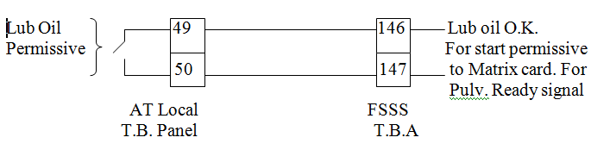

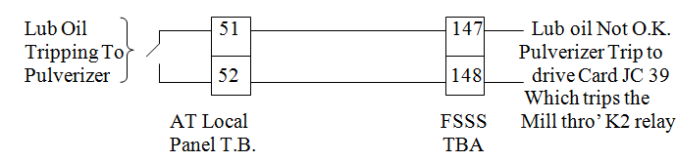

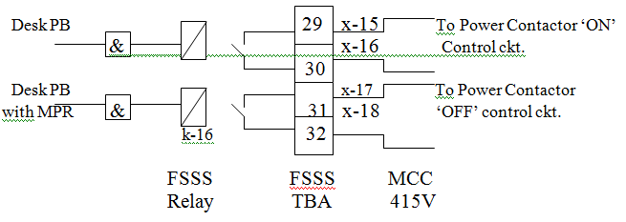

**Both ‘ON’ & ‘OFF’ commands goes to MCC via Local Panel T.B.**

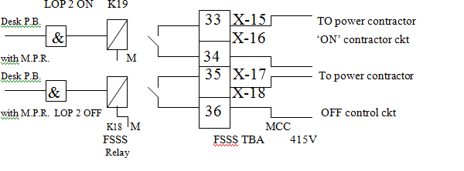

Feedback AT FSSS TBA

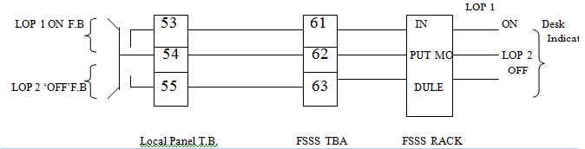

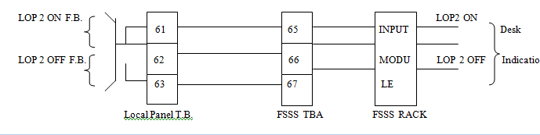

To Each Local Control Lop Panel, 110v A.C. Supply is made available thro A.C.D.B. situated in P.C.R. In Panel ON/OFF Switch is provided for A.C. Supply to have pick up/ drop off of 110v Relays.

In modified F.B. ckt. ON/OFF F.B. are taken from M.C.C. Relay.

COAL FEEDER ‘A’ CONTROL:-

Each pulverizer is provided with one feeder which can be controlled auto or manual. Feeder can be started or stopped from control desk or from switchgear MCC or from Local.

The speed of feeder is varied on auto as per demand or annually from control desk for this three feeder panel each comprising tow feeder control circuit is provided in P.C.R.

Before starting the feeder the following condition should be satisfied.

* 1. Pulverizer ready with manual mode select.
  2. H A G opens.
  3. Run feeder speed demand to minimum.
  4. No MER Trip.
  5. Pulverizer ON.

Feeder is started by pressing ‘Feeder ON’ P.B. on desk. Feeder speed is raised manually & then put on auto control.

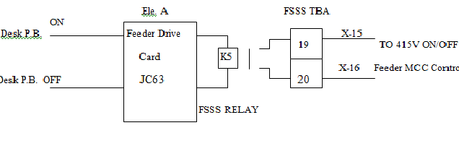

As soon as Feeder is made ON, its auto or manual speed control is through Feeder speed control circuit. Dendrite controls the speed of feeder as per demand on auto or manual. For this, a feedback from techno generator which is mounted on dendrite is used to give signal to exciting coil of eddy current drive.

Feeder Tripping:-

1. ‘OFF’ Feeder Pulse
2. Pulverizer OFF.
3. Electrical Protection i.e. Th. overload.

Feeder speed comes to minimum if pulv. Motor current is high.

MASTER FUEL TRIP (MFT)

The master fuel trip (MFT) is established when abnormal boiler conditions dictate that all fuel input to the boiler be removed immediately and automatically. The MFT command will cause the following events to occur.

1. All fuel input to the unit is stopped by tripping all pulverizer all feeders and closing both the trip valves. The oil elevations are also tripped.
2. All pulverizes are rejected to manual mode. This causes all the oil elevations to go to pair mode.
3. All the P.A. Fans are tripped.
4. All pulverizes cold air dampers are opened to 100% open position after a 5 minutes time delay.
5. After a two second time delay, all auxiliary air dampers and fuel air dampers are opened 100%.
6. After fire seconds, a feed forward signal to the furnace draft control is established. The signal is removed after thirty second counting period is over.
7. For a 30 sec. counting period the furnace pr. recorder speed is increased, If the furnace pr. is not high or not low when the 30 sec. counting period expires the recorder resumes normal speed.

Any of the following conditions will initiate an ‘MFT’.

1. All ID fans off.
2. Both FD fans off.
3. Emergency trip given by an operator.
4. Furnace pressure very low.
5. Furnace pressure very high.
6. Reheat protection trip.
7. Simulation trip

Note: - When the boiler is in operation if simulation is attempted in unit section suing the simulation module the boiler will trip. If simulation is attempted in any oil elevation or coal elevation. That particular elevation will be tripped.

Fuse failure in input modules connecting trip conditions:- If there is a fuse failure in input modules as a result of ground fault or cable fault which connect the primary sensors/ contacts used for tripping the boiler to FSSS, the boiler will trip. If there is a fuse failure in any other input module, then a group fault alarm will be annunciated.

1. Drum level v. High.
2. Drum level v. Low.
3. Loss of unit 220 v DC power for more than 25 sec.
4. Low air flow i.e. air flow less than 30%.
5. Unit flame failure tripe.

Note: - The unit flame failure trip gets armed when any feeder is proven on (on for > 50 sec). After this the unit flame failure trip exists when all the six elevations listed below along with arming gives a “flame failure” vote.

Elevation “A” votes flame failure when anyone of these conditions exits.

1. Feeder “A” not proven for more than 2 secs.
2. 2 out of 4 H.O. or L.O. nozzle valves in Elevations AB not open and fire ball scanner in elevation “AB” shows no flame.
3. Elevation AB started and loss of elevation AC power for more than 2 seconds and elevation AB started fireball scanner show no flame.

Elevation “B” votes flame failure when anyone of these conditions exist.

1. Feeder “B” not proven for more than 2 sec.
2. 2 out of 4 HONV not open in elevation “A” and elevations AB < BC fire ball scanner shows no flame.
3. Elevation AB started & loss of AC power for more than 2 seconds and elevation AB & BC F.B. scans to flame.

Elevation “C” votes flame failure when any one of these conditions exists.

1. Feeder C not proven for more than 2 sec.
2. 2 out of 4 HONV not open in elevation CD and elevation BC scanners show no flame.
3. Elevation CD started and loss of AC power for more than 2 sec. and ele. BC scanner shows no flame.

Elevation “D” votes flame failure when any one of these conditions exists.

1. Feeder D not proven for more than 2 sec.
2. 2 out of 4 HONV not open in elevation CD and elevation CD and DE fire ball, ball scanner shows no flame.
3. Elevation CD started and loss of AC power for more than 2 sec. and elevation CD and DE fire ball scanners show no flame.

Elevation “E” votes flame failure when any one of these conditions exists.

1. Feeder E not proven for more than 2 sec.
2. 2 out of 4 HONV not open in elevation EF and elevation DE and EF fire ball scanner shows no flame.
3. Elevation EF started and loss of A.C. power for more than 2 sec. and elevation DE and EF fire ball scanners show no flame.

Elevation “F” votes flame failure when any one of these conditions exists.

1. Feeder F not proven for more than 2 sec.
2. 2 out of 4 HONV not open in elevation EF and elevation EF fire ball scanner shows no flame.
3. Elevation EF started and loss of A.C. power for more than 2 sec. and elevation and EF fire ball scanners show no flame.

LOSS OF FUEL TRIP

Note: - Loss of all fuel trip become armed when at least three out four nozzle valves are proven open on any elevation in service. The loss of all fuel triop exists when all of the following conditions exist: -

1. All feeders are off.
2. Light oil trip valve closes or all HONV closed in elevation AB.
3. Heavy oil trip valve closed or all HONV closed or back up trip in all the three oil elevations.
4. Loss of fuel trip arming.
5. Less than fire ball and loss of A.C. or 24V DC at any elevation in service.

Note: - Above condition exits when both the following conditions are present.

1. All feeders are off.
2. Any elevation (either oil or coal) started and loss of elevation AC power for more than 2 sec. or loss of elevation +24V DC power.
3. Loss of unit critical power (+24V DC).

FIRST OUT CAUSE OF TRIP SYSTEM

The first out cause of the trip is determined and displaced on unit console inset (First out monitor). All subsequent trip commands to the first out trip system will be blocked. This first out indication disappears (got resettled by setting F/F) when purging is completed.

SCANNER FAN CONTROL

Two scanner fans serve this unit. They can be placed in service when the following conditions are established.

1. The operator can start either scanner fan by momentarily depressing the associated start push button on the unit console insert.
2. Both fans will receive a start command if unit critical power (+24V DC) is lost.
3. Scan fan A will receive a start command if the scanner duct to furnace differential pressure is below 6 WC. After 10 sec. an alarm is annunciated.

If either scanner fan remains off for 5 sec after it receives a start command then a start command is given to the other scanner fan (A or B) start signal is sent to DAS. If the other fan also remains off for 5 sec. after receiving start command then unsuccessful scanner fan (B & A) signal is sent to DAS along with redundant start signal to the first fan. At this time operator should take necessary action.

The scanner emergency damper will receive an open command when unit critical power lost or both FD fans are off. The damper will be closed when the above conditions do not exist.

The operator can stop either of the running fans by depressing the respective stop push button on the unit console insert provided the scanner duct to furnace differential pressure is not low (< 6” WC).

SECONDARY AIR CONTROL

AUXILIARY AIR DAMPER CONTROL

All elevations of auxiliary air damper will automatically switched to ‘manual’ control from ‘Auto’ control and commanded to open 100% when any of the following condition exist:-

1. Both FD fans are off.
2. Both ID fans are off.
3. A’ Master fuel trip’ condition exists for more than 25 sec.
4. Unit critical power is lost for more than 2sec

When the auxiliary air control is placed in the ‘Auto ‘mode of operation the auxiliary air damper modulate to control wind box to furnace differential pr. at a predetermined set point. During the furnace purge cycle and when unit load is below 30% of full load all auxiliary air dampers modulate to control wind box to furnace D.P. at a predetermined set pt.

When the unit loads exceeds 30% of full load the following events occur.

1. The wind box to furnace d. p. set pt. is gradually increased as the unit load is increased. Conversely, the D .P. set pt. gradually decreased as unit load is decreased. This rate incr. dear. is controlled by Auxiliary damper controller.
2. a) The auxiliary air damper on ele. AA, BC, DE and EF Are closed coal ele. are not in service.
3. The auxiliary air damper on elevation AB, CD and EF are closed in a timed sequence close intervals) provided the associated coal elevation are not in service and the associated coal elevation are not in service. CH.O. ELE. Back up trip condition exists) the auxiliary air closed starting at the top elevation and progressing Towards elevation , when unit load is reduced below 30% of full load the following events occur.  
   1) The wind box to furnace differential pressure set pt reverts (comes) to its original value.
4. The auxiliary air damper associated with coal aw H.W. ele. Not in service are opened in a timed sequence (ten sec. interval) starting form lowest to top elevation.

FUEL AIR DAMPER CONTROL

ALL elevations of fuel air damper are commanded to open 100% when any of the following condition exists.

1) Both F.D. fans are off

2) Both L.D. fans are off.

3) A ‘Master fuel trip’ condition exists for > 2 sec

4) Unit critical power is lost >2secs.

When a feeder is proven (feeder ON for more for than fifty seconds), the feeder is released to ‘AUTO control. The associated fuel air dampers modulate as a function of feeder speed, as indicated by the associated coal elevation (red) ‘MOD’ light on and the green ‘CLSD light off.

When a feeder is off for more than fifty sec the associated fuel air dampers air closed (green’ CLSD’ ON)

When a feeder is off for more than fifty seas the associated fuel air ‘Post trip purge time expired’ command is established and both F. D. AND I.D. fan air not off and a ‘Master fuel trip’ command exists for more than two seconds , then the ‘open upper fuel air damper (ele. D, E, F,)’ command removed from memory. Thirty second later, the ‘open lower fuel air damper (ele. A. B. C.)’ Command is memory form memory.

SEAL AIR FAN CONTROL

Seal air system has 3 seal air fans.

Before taking the first mill in service, at least one seal air fan should be started manually by depressing the start push button and before taking 4th mill in service, seal air fan should be started.

Once any one seal air fan has been started, and still the seal air pr ( ) is low for more than 10secs. The second fan gets start command automatically,

It fan A gets start command but does not start, after 5 sec, fan c gets start command

If Fan B gets a start command but does not start, after 5 sec, Fan C gets start command.

If Fan C gets a start command but does not start, after 5 sec, fan A gets start command.

If any one of the two running seal air fans trips or seal air header pr is low & the third seal air fan does not start the mill will get trip command from top down wards.

Manual step is possible when pr is O.K. and

1. 2 or 3 seal air fans & less than 4 mills in service
2. 1 seal air fan and no mill in service.

Each seal air fan has its outlet damper whenever any seal air fan is started, the O/L damper gets close command. After 10 sec it gets a open command.

Whenever seal air fan is stopped, O/L damper gets close command.